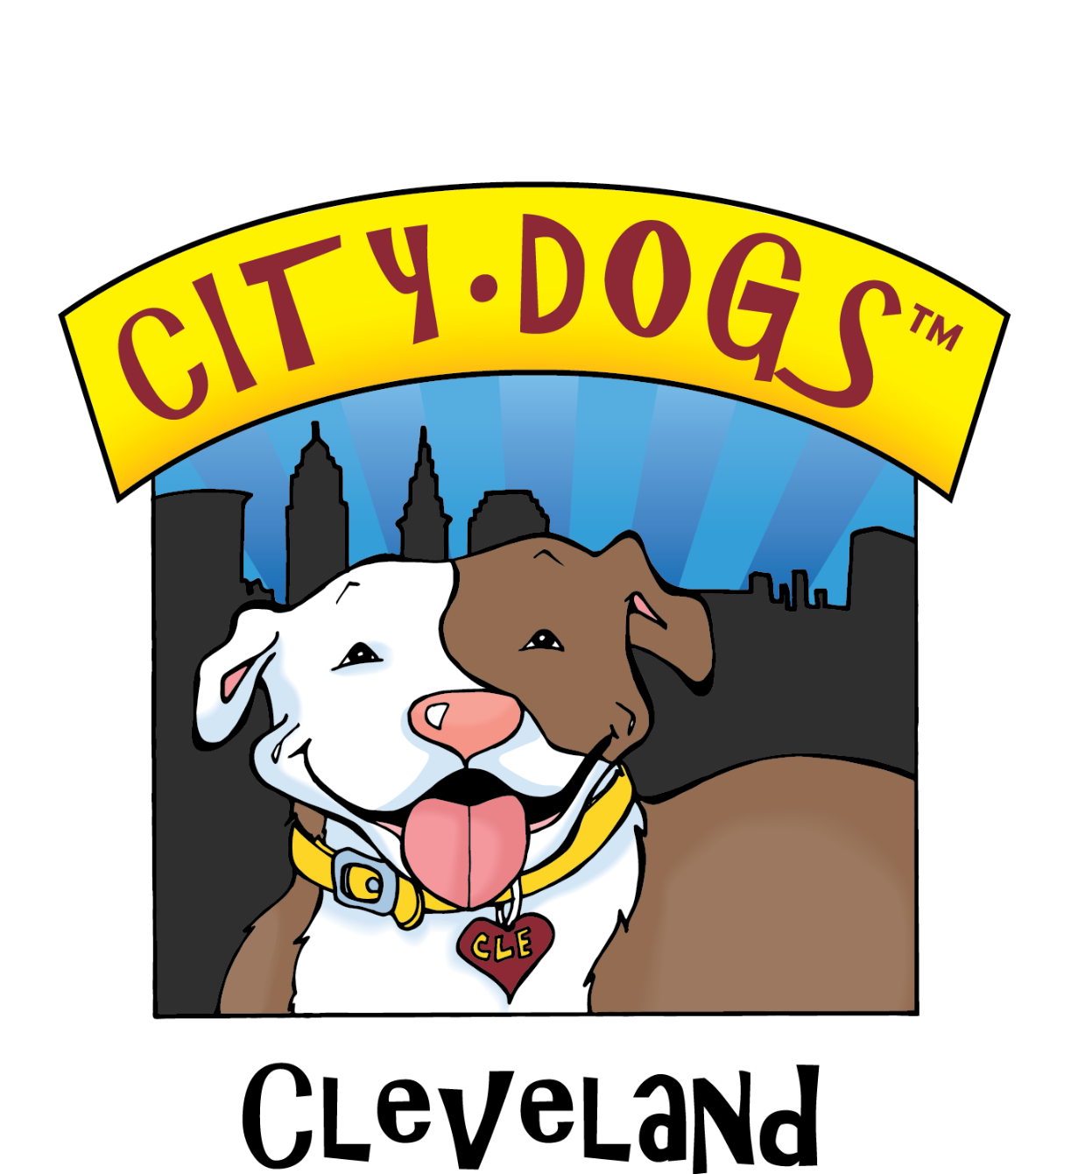
CITY DOGS MARKETING STRATEGY PROJECT
Harnessing our marketing efforts for the long run

KICK-OFF QUESTIONNAIRE

KICK-OFF QUESTIONAIRE

Thanks for participating in the effort to strengthen City Dogs’ marketing communications program.

We can’t know which way to go without having a sense of where we stand, so please take adequate time to thoughtfully answer as many of the questions below as you feel you have something you want to share.

1. Please type your answers in RED after each question, then:
2. Save this WORD doc with your name added to the file name, then:
3. Email to rdemuesy@sbcglobal.net by April 24

How long have you been volunteering/working at City Dogs? How did you first learn about City Dogs?
Answer …

Based on what you know/feel:
—what’s the difference between APL, County, City Dogs?
Answer …
—What is each shelter best at or known for?
Answer …
—How does/can each shelter complement the other?
Answer …
—Any notion of how the public thinks/feels about each?
Answer …
—Is the term ‘dog shelter’ an adequate description? Why or why not?
Answer …

What is the job of Animal Care & Control?
Answer …

What is the job of City Dogs?
Answer …

The myths about Pitties
—What do you think are the top three myths?
Answer …
—How prevalent (or not) do you think these misunderstandings still are today?
Answer …
—Do we need to address/answer them somewhere in our marketing communications? Why or why not?
Answer …
—Was there any particular myth you bought into, and then found it/yourself blown away when you met your very first pittie?
Answer …

On finding fosters:
—What kinds of things have been done in the past to find/entice fosters?
Answer …
—What’s worked?
Answer …
—How do you know it’s worked?
Answer …
—Why would anybody foster a dog?
Answer …

On attracting adopters:
—What kinds of things have been done in the past to find/entice adopters?
Answer …
—What’s worked?
Answer …
—How do you know it’s worked?
Answer …
—Why would anybody adopt a dog from City Dogs?
Answer …

On gaining volunteers:
—What kinds of things have been done in the past to find/entice volunteers?
Answer …
—What’s worked?
Answer …
—How do you know it’s worked?
Answer …
—What would the optimum number of volunteers be to maximize the effectiveness and success of City Dogs?
Answer …

On fundraising (public and corporate)
—What kinds of things/events/activities have been done in the past to encourage public donations?
Answer …
—What’s worked? What hasn’t?
Answer …
—What kinds of things/events/activities have been done to attract/build/maintain corporate sponsorships?
Answer …
—What’s worked? What hasn’t?
Answer …

What single City Dogs marketing element do you believe excels more than all the others? Why do you say that?
Answer …

What’s the best promotional idea for any shelter you’ve ever seen? What did you like best about it?
Answer …

What is your reason for showing up to City Dogs?
Answer …

How did you first hear of City Dogs?
Answer …

What element of City Dogs makes you proudest to volunteer here?
Answer …

Who are we?
Of these choices in the wheel below, which 3 does City Digs most embody … and why?
Pick/rank/explain from #1 to #3 …

#1 Answer ...
#2 Answer …
#3 Answer …

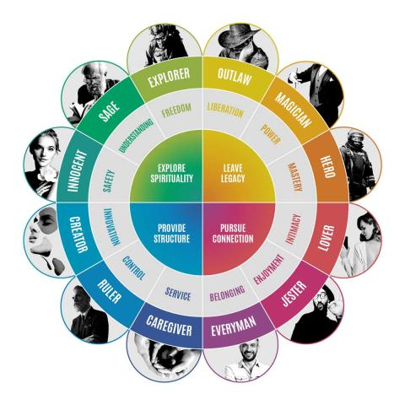

THANK YOU FOR YOUR FEEDBACK!

Your input will aid in creating an agenda for a 4-hour Branding/Marketing
Workshop with those volunteers and staff already active or interested in the marketing of City Dogs and Animal Care & Control.

The goal of the Workshop will not be to come away with all the answers, but know for sure what questions we need to focus on answering to further hone, understand and clearly articulate our purpose, target audiences, and meaningful messaging points.

We can also identify people with particular skills sets and begin forming an expanded, dedicated, coordinated marketing ‘team’ with specific responsibilities.

If you would like to participate in this 4-hour Workshop, please include your email address to receive details on when and where it will be held.

Your email: who@where.what

